<Cohort Management Portal>

<SOI-2020-2020-0042>

Date of Submission: 02-02-2021

Submitted By:

SOI-2020-0003

18009175 LAM HUEY HING

18008948 CINDY CHUA LI PING

18021951 ANNE CHRISTINE ESTRADA SATO

18008489 SYED SHRIN FATHIMA

|  |  |
| --- | --- |
|  |  |
|  |  |
| <student_id> |  |
| <student_id> |  |

**ACKNOWLEDGEMENTS**

**Section Explanation:** You may want to thank those individuals who have assisted your team during your project. You could also mention any organizations that have helped you while you have been carrying out the project.

We would like to show our utmost gratitude to our Project Supervisor, Shang Ong for accompanying us throughout this journey. We would not be able to complete this project without the support and guidance from him. Furthermore, we would also like to show our gratitude to our evaluator, Peter Liew and Marlina.for taking time out into evaluating our project and providing feedback to us.

TABLE OF CONTENTS

ACKNOWLEDGEMENTS. 2

ABSTRACT. 4

1 Introduction. 5

2 Project Specification and Plan. 6

2.1 Project Overview.. 6

2.2 Functional Requirements. 6

2.3 Project Plan. 7

3 Business Analysis. 8

3.1 Business Issues. 8

3.2 Market Analysis. 8

3.3 Business Solutions. 8

4 System Design and Implementation. 9

4.1 System Architecture. 9

4.2 Detailed System Design. 9

5 System Testing. 10

6 User and Technical Documentations. 11

6.1 User Documentation/Guide/Manual 11

6.2 Technical Documentation (Installation guide/Manual) 11

7 Conclusions. 12

References. 13

Appendices. 14

Project Poster 15

# **ABSTRACT**

**Section Explanation:** The executive summary is also known as an abstract of your report. It is a brief summary of the report’s contents. It should be about half a page long (should be about 250 words or less). The reader should be able to understand what the project is about, how it was undertaken and what was accomplished. The abstract should answer the following questions:

• What is the project about?

The project is about developing a web-based interactive portal that is called Cohort Management Portal (CMP). This project will aid in the execution of the partner's program. The operations team will help to manage startups throughout the program without the need to send repeated text reminders to the end users.

• How is the project implemented?

The project will be implemented and run on Visual Studio, and the web page will display on Google Chrome.

• What did the project accomplished?

The project has accomplished a couple of things such as creating a login page,home page, events page for the portal, admin of the portal is able to maintain the programs schedule such as add events,edit events and delete events in the events page. Admin can able to send event invitations to the end users and they also can manage the attendance of the attendees for each program inside the portal in terms of the status of attendance for the end users whether they have attended the program or no show to the program. There is an upload feature included for the admins to upload the program details for each program.

• Final status of the project and recommendations (if any)?

# **1** **Introduction**

**Section Explanation:** The introduction should tell the reader what your project is about. The introduction should answer the following questions:

• What exactly is the problem that your project is trying to solve?

Due to covid situation, programs made by Tribe Accelerator company were not able to run efficiently due to lack of audience who are unable to attend the programs since they are not aware of the program schedule or they did not get a reminder for the events that they have signed up for, thus this might cause them to forget to attend those events.

• Why is this problem important to solve? This is the motivation of the project.

This problem is important to be resolved because Tribe Accelerator programs are beneficial for SME businesses as attending these events will be productive for startups to develop their businesses to earn more profit. Hence this project helps Tribe Accelerator programs to be available for its customers in online platforms since this project is about a website portal, so customers can easily assess information about the events inside the program schedule, they get to know about events details and they are able download event materials whenever they want.

• What are the major tasks and deliverables of the project? This is the project scope.

Major Taks: Access program schedule, Indicate Attendance for events,Receive automated reminders for scheduled events, Provide post-event feedback, Download program materials, Receive invites for events, Indicate attendance for events, Receive automated reminders for scheduled events, Upload & update program schedule, Collate event attendance, Send (and integrate with Google and Outlook Calendar) automated reminders for scheduled events, Upload program materials, Collate post-event feedback Proposed

Project Scope: A website portal that displays program schedule, elaborates event details, has features to upload/download event materials and displays attendance status of the end users.

Deliverables of the project: Responsive web application based on its requirements.

• How have you solved the problem? This is your approach. You should expand on this in the later sections (project strategy, plan and design)

My team have resolve this problem by developing a website portal which is accessible by the registered users, where they can view program schedule(build an page which displays recent events), they can read up about each event and able to sign up for that particular event from the sign up button given in the event details page(build an event details page where inside there will be provided detailed description of that event and there will be also a sign up event feature where end users can click it and sign up for the event that they would like to attend). Furthermore, we have built a download feature in the event details page, where end users can download event materials if they would like to check out reference documents about that particular event. In addition, we have built my account page where end users can edit their personal particulars if there are any changes to be made.

• What are the conditions under which your solution is applicable? This is where you list the assumptions made, if any.

**Conditions** such as in our solution, for collating the attendance report, it will be made from MS Teams Meeting features where at the end of the event , the organiser of the event can be able to download the attendance report, so our solution will be more suitable for events which is held by MS Teams Meeting.

**Assumptions** such as the firstly, the company will provide the program details so that it will be easy to add into the programs into our solution so that our solution will be applicable in reality. Secondly, if our solution is approved by the company then the company should extend the deadline for us to add in some more features in our solution in order to be completely ready for launching. Lastly, we assume our solution is within the project budget expected by the company.

• What are the main results? This is where you list the main deliverable points.

The main results of our solution is that it can be implemented successfully. It is a responsive web application, where the audience is able to assess information. It has met all the requirements of the project, such as 1. Access program schedule, 2. Indicate attendance for events, 3. Receive automated reminders for scheduled events, 4. Provide post-event feedback, 5. Download program materials, 6. Receive invites for events, 7. Upload & update program schedule, 8. Collate event attendance, 9. Send (and integrate with Google and Outlook Calendar) automated reminders for scheduled events, 10. Upload program materials, 11. Collate post-event feedback.

# **2** **Project Specification and Plan**

**Section Explanation:** Students should read and understand the requirements in this section and set achievable deliverables with the Supervisor. Some of the deliverables that the students and Supervisors should agree upon before the start of the Project are listed below but not limited to:

• Extent of business analysis

• Extent of technical analysis, design and implementation

• Tools and techniques used in analysis

• Resources such as web server etc.

• Optional items listed in this guidelines that can be omitted from the report

This section should be completed between 1st and 2nd meeting

• Project Overview

• Functional Requirements

• Project Plan

## **2.1** **Project Overview**

**Section Explanation:** This subsection should contain a brief description of the system being developed and its purpose, including information such as:

• Project Motivation (Why do the project? what are the benefits?)

The Cohort Management Portal is needed to help operations and startups (intended audience) to interact and manage without having to send repeating messages. One benefit that the program is the execution of the partner’s program. Moreover, the alumni of the tribe accelerators can access the program.

• Project Objectives (What is the project trying to accomplish?)

The objective of this project is to help alumni, startups and the operations teams to interact with each other and utilize the program seamlessly. It also aims to support the startup and alumni in their learning.

• Project Scope (What are the major tasks and deliverables of the project?)

1. **User Registration to Cohort Management Portal** - New Users registering into the Cohort Management Portal are required to register with their email and other user details
2. **User Views Programs**- Registered users (startups and alumni) can view the list of events according to event name, start time, end time and venue. Users can also view the event details for more information
3. **User View Program Schedule** (Program Details) - Registered users can view the program information such as its event description, start time, end time and venue.
4. **User Registers for Events** - Registered users can sign up for events in which they require to input their email and password? A confirmation email will be sent to the user once the user submit their sign up details.
5. **Admin upload materials** - Admin upload materials for each event and registered users can download those uploaded materials for their own use
6. **Google / Outlook API Integration** - Google or outlook calendar is integrated with the program to help users mark the date of events and also send in reminders of the events they have registered.

• Project Assumptions (Are there assumptions which are made regarding how the end deliverable will work, etc.?)

One assumption would be that the operations team will be in charge for uploading the materials. This is because there are different materials to be uploaded in each event. Second assumption is that users may download all files or only one or none for each event.

## **2.2** **Functional Requirements**

**Section Explanation:** This subsection should clearly specify the major functions the system should possess. Business rules or business requirements must be documented. Students are encourage to use tools such as Use Case diagram to document the business requirements.

**Major functions of the system** are 1. Access program schedule, 2. Indicate attendance for events, 3. Receive automated reminders for scheduled events, 4. Provide post-event feedback, 5. Download program materials, 6. Receive invites for events, 7. Upload & update program schedule, 8. Collate event attendance, 9. Send (and integrate with Google and Outlook Calendar) automated reminders for scheduled events, 10. Upload program materials, 11. Collate post-event feedback

## **2.3** **Project Plan**

**Section Explanation:** This subsection describes in detail the schedule, milestones and work allocation of each member of the team. Care must be taken to prepare this as each member of the team will be evaluated independently based on his/her contribution, effort, teamwork amongst other factors. This subsection will also serve as a basis where teams and supervisors can monitor progress being made. The use of MS Project is recommended.

In the Microsoft Project, you may include the following:

• List of tasks need to be assigned to a particular team member

• Ensure that there is adequate and fair involvement by each team member

• Project Plan must take into consideration the deliverables at specific milestone such as the 3 meetings

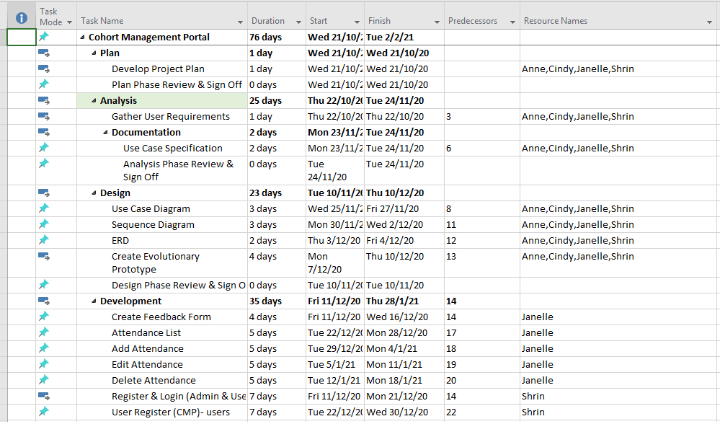

# **3** **Business Analysis**

**Section Explanation:** This section is applicable to projects in domains such as Application Development, Data Analytics & Visualisation, IoT (Sensor driven applications), IT Security, Mobile App, and Solution Implementation.

This subsection describes the business analysis done to address the business issues of the project. It should contain the following but not limited to:

• Business Issues & Market Analysis (optional, Supervisor to decide)

• Business Solutions

## **3.1** **Business Issues**

**Section Explanation:** This subsection describes the current business situation with special emphasis on the issues that the project is trying to solve. Some consideration includes:

• Provide more detail on the current situation

• What are the difficulties or business issues that we are trying to solve?

Difficulties when we face during developing our solution is that, some functional requirements were hard to meet such as firstly, download event material feature, previously in our .net programming module we were not taught of this feature on how to develop it therefore we had to research on our own to come out with the codes that helps in creating this feature. Secondly, we were not sure how to begin with the codes on the requirements such as Collate event attendance and Collate post event feedback because we only know that usually in terms of collate attendance report, we have seen in MS Teams app, which enables us to download the attendance file at the end of the meeting but in our project case it is not only base on MS Teams event so beside that we find it hard to how to develop such collating documents. Lastly, base on the requirement such as send automated reminder, it uses Calendar API software, which is another topic that was not covered in our previous modules that we had learnt, therefore we thought of giving up as we know that we will not be able to develop this function, however our supervisor had mention in our 1st FYP meeting that he will be teaching how to able to develop such unique function like sending automated reminder which integrate with Google and Outlook Calendar, thus he told us that, after developing a solution that meets the basic functions of the project that it will be a bonus to include the Calendar API into our solution to make it more attractive and it would get our team a higher grade in the graded assessment.

## **3.2** **Market Analysis**

**Section Explanation:** This subsection describes the size of the business solution. The following may be included in this subsection:

• Size of business and market segment

**Business Size**: Tribe Accelerator’s company size is about 11-50 employees.

**Market Segment**: Tribe Accelerator’s capabilities and direction aligns with our long-term vision to bring business-blockchain to the forefront of market operations. Tribe Accelerator has invested in 19 startups from two batches with a combined value of more than $300 million. Tribe also runs a blockchain academy with scholarships available to developers across Southeast Asia. Tribe Accelerator is a go-to-market focused accelerator that provides our portfolio companies a hyperconnected platform to accelerate their innovative use cases through our global network of MNCs, government agencies and top tech companies. Promising growth-stage startups with market-ready blockchain solutions can tap into the three firms’ networks and either integrate their solutions into existing business units or tailored as end-user products. Where Tribe Accelerator has gained advantage and confidence from industry partners such as IBM, Citibank and Ubisoft as our latest corporate partners re-affirms that we are taking Singapore’s business-blockchain journey to new heights.

• Competitive analysis

**Company Background**:Tribe Accelerator is a company that provides a platform for collaboration and growth of the blockchain ecosystem.

**Established**: 2018, **Type**:Private, **Services**: Business Products & Services (Accelerator/Blockchain)

**Competitors;**

1. **Startup Haven** is a company that offers accelerator programs for startups.

Established: 2006, Type:Private, Services: Business Products & Services (Accelerator)

1. **CryptoBazar** is a company building a platform, where businesses receive money for ICO and investors fund blockchain-based projects

Type: Private, Services: Financial Services (Accelerator/Blockchain & Event Management)

1. **Wecan** is a company that specializes in the development of blockchain joint ventures.

Established: 2015, Type: Private, Services: Investment (Accelerator/ Blockchain & Fintech)

1. **300Cubits**: A blockchain solution to help resolving $23b pain point in the $150b shipping industry

Founded: 2017 / Company Size: 1-10 Employees / Industries: Enterprise software, Blcokchain, Transportation, Marketing & Retail

1. **50 Partners:** Is a leading startup accelerator in France. The program provides a few selected startups with high quality mentoring, financing, international connections, networking and office space in central Paris. 50 Partners is a dedicated ecosystem for innovative tech projects, where entrepreneurs, VCs, corporates and industry experts are committed to help startups succeed.

Founded: 2019 / Company Size: 81-100 Employees / Industries: Consulting, Hosting, Enterprise software,Realestate, Telecom

1. **Accelair:** Accelair will host start-ups developing breakthrough technologies in areas related to energy and environmental transition, industry 4.0, aerospace, agribusiness, and healthcare. It will welcome approximately twenty start-ups, which will benefit from dedicated workspaces such as individualized experimentation laboratories, collaborative spaces, a fab lab and a pitch zone. Moreover, this new accelerator will include a personalized support program with Air Liquide experts and partners, with the aim to enable start-ups to reduce the time required to industrialize their offer.

Founded: 2019 / Company Size: 11-20 Employees / Industries: Energy & Healthcare

1. **42 entrepreneurs**: School 42 is a rich source of talent and skills. We bring together students who are curious about entrepreneurship, such as those who have already joined a startup or started their own. Through conferences, meetings, workshops, competitions, or hackathons, we stimulate their entrepreneurial spirit. We build a community that encourages its members to test their ideas and achieve their ambitions.

Founded: 2014 / Company Size: 1-10 Employees / Industries:Finance, Enterprise software & Blcokchain,

1. **Accelerator Academy:** tasked with Educating Emerging Entrepreneurs. A 12 week part time intensive training programme for ambitious entrepreneurs and early stage businesses from the tech, digital, social, ecommerce, media, mobile & amp; marketing sectors. Working with first year businesses, the Academy helps entrepreneurs to proactively tackle growth challenges and build a business capable of serious scale and more likely to attract appropriate investment backing.

Founded: 2011 / Company Size: 1-10 Employees / Industries: Marketing & Media

## **3.3** **Business Solutions**

**Section Explanation:** This subsection describes the business solution to the problem. Students are expected to demonstrate their ability in understanding the business logic and the process. Some important consideration is to understand the overall business process and not just the IT solution. The following may be included in this subsection

• Process flow

***CMP- User Process Flow:***

Register Account -> Sign-in to Portal -> View Program Schedule -> Register for Event -> Download Event Materials -> Attend Event -> Submit Post Event Feedback

***CMP- Admin Process Flow:***

**Event:**

Add Event -> (Update Program Schedule/ Delete Program Schedule) -> Upload Event Materials

**Attendance:**

View Attendance List -> Add Attendance -> (Edit Attendance/ Delete Attendance)

**Feedback:**

View Feedback List

• How IT can help

We use Programming software, the Visual Studio to perform these functions. Some other IT that we work with also includes Internet, Network and databases.

# **4** **System Design and Implementation**

**Section Explanation:** This section describes the architecture and the design of the system. It will briefly describe the various hardware and network interaction.

<This section is Zip in the submission Folder>

1. Prototype
2. Use Case Diagram
3. Sequence Diagram
4. Use Case Specifications
5. ERD Diagram

## **4.1** **System Architecture**

**Section Explanation:** This subsection describes the interaction between the different hardware. At the same time, it will describe the network topology that will be used by the system.

## **4.2** **Detailed System Design**

**Section Explanation:** This subsection includes the design documentation for the project. Care must be taken to ensure that the diagrams are clear and carefully organized.

• The following tools can be used to help in design:

• Entity Relationship Diagram

• Use Case Specification

• Unified Modelling Language Tools (e.g. Class Diagram, Sequence Diagram, only for OOP project)

• Data Flow Diagram

• Control Flow Chart

• Decision Table/Tree

• Pseudo Code

# **5** **System Testing**

**Section Explanation:** This section describes how the system will be tested for robustness and fulfilment of functional and system requirements (Test Plan).

<This section is Zip in the submission Folder>

You may use the Sample Test plan for reference, and use RP Test Specification Template for Unit / Functional Testing.

From Freelancer.com

(formerly RentACoder.com)

Other Resources for reference on Software Debugging and Testing:

<https://en.wikipedia.org/wiki/Software_testing>

<https://braydie.gitbooks.io/how-to-be-a-programmer/content/>

<http://www.extremeprogramming.org/rules/unittests.html>

# **6** **User and Technical Documentations**

## **6.1** **User Documentation/Guide/Manual**

**Section Explanation:** A user documentation or manual should be produced to describe how the system should be used. It should be readable and understandable by a non-technical person (i.e. someone who is IT illiterate). Illustrations and graphics can be used to great advantage here.

1. **For Startup Founders and Alumni(USERS)**
   1. **User Registration to Cohort Management Portal**

From the Home page, click the ‘Register’ button on the left side of the page

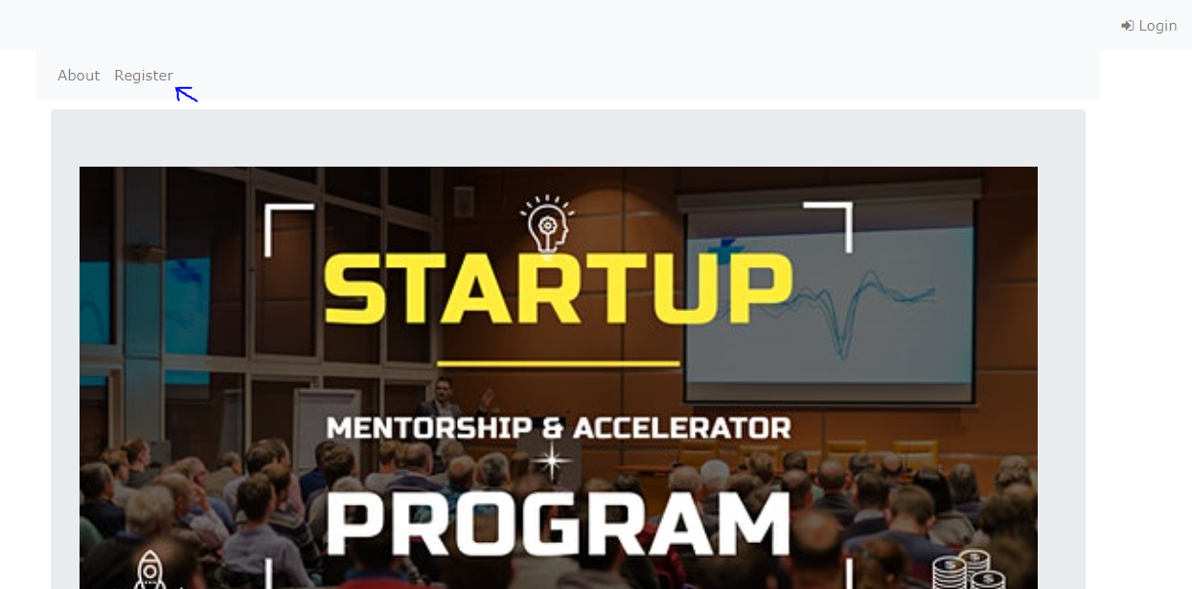

User fills in particulars, then clicks ‘Register’ to submit user particulars.

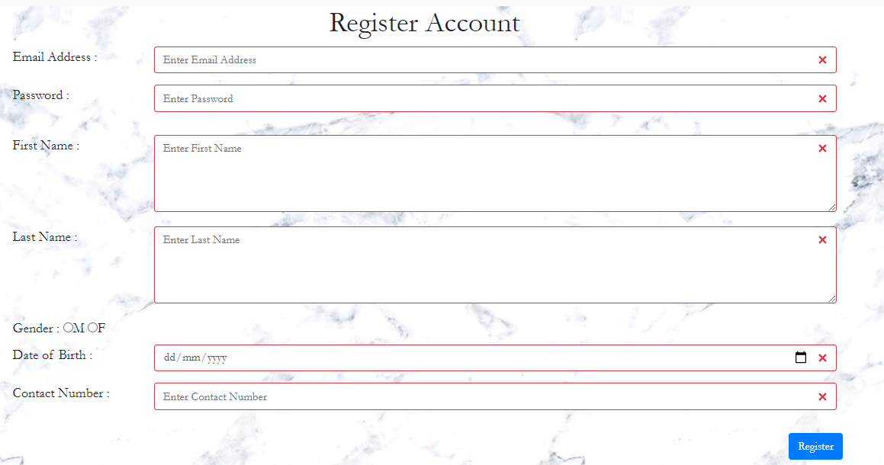

Users should receive a confirmation email via Outlook after registration.

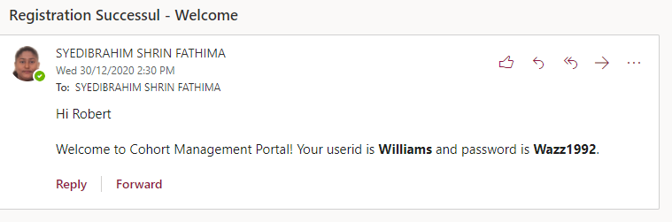

* 1. **User Views Events**

Go back to the Cohort Management Portal Home page and select the ‘ProgramsList’ button.

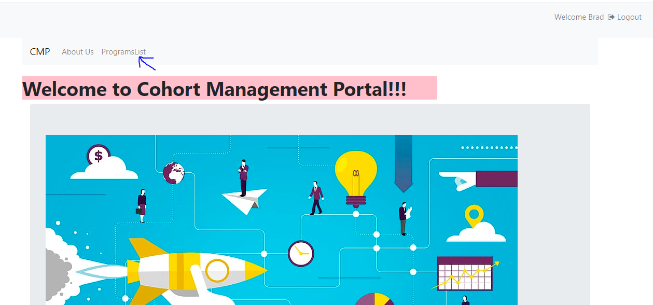

Users should see a list of events on the page.

From here, users may search for any events in the page by keying in the search bar.

Alternatively, users may click each column header to sort list details in order.

Also, users may adjust the number of rows by selecting the number of entries.

To view the next page click on the page buttons or click the arrows.

**1.3 User View Event Details**

From the list of events, click the name of the event.

The link of the event name should direct the user to a page that shows the event details which includes the event description, start & end time and venue.

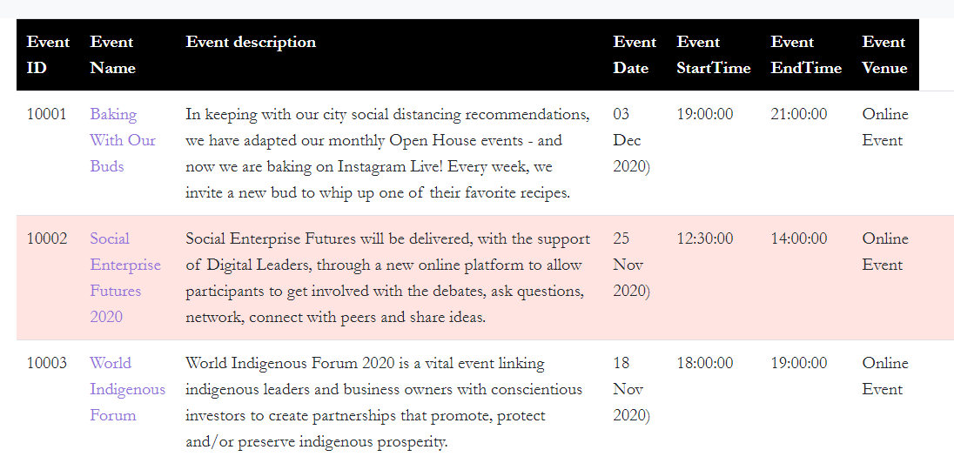

**1.4 User Download Event Materials**

From the event details, click on the ‘Resources’ link.



Users should be able to see this lists of files below

To download files, click the download icon. The program can only download

each file from its respective row in the files list .

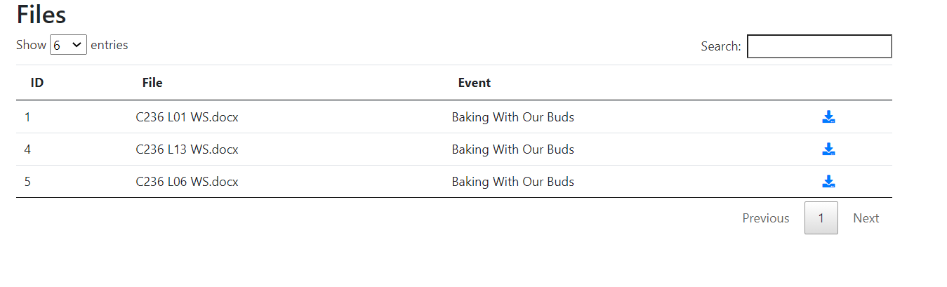

**1.5 User Registers for Events**

Go back to the list of events. Users should be able to see the ‘Register’ button on the right side of the page.

Click the ‘Register’ button.

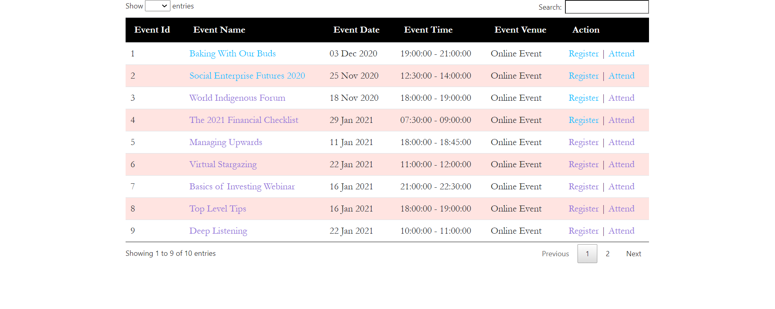

A message will be shown to indicate that the user has successfully registered for the event.

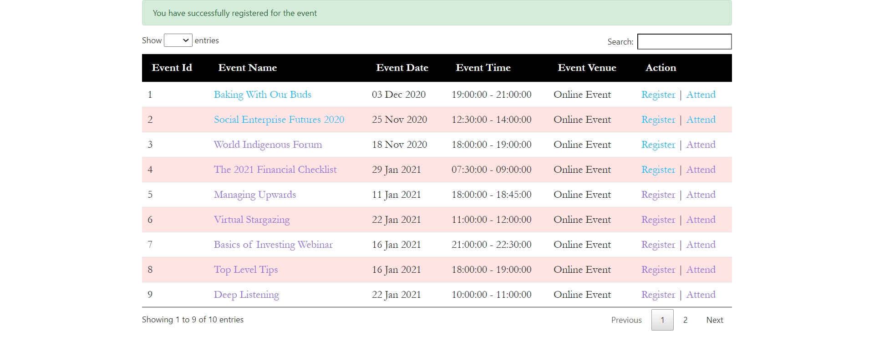

The registration will automatically be added to the attendance list.

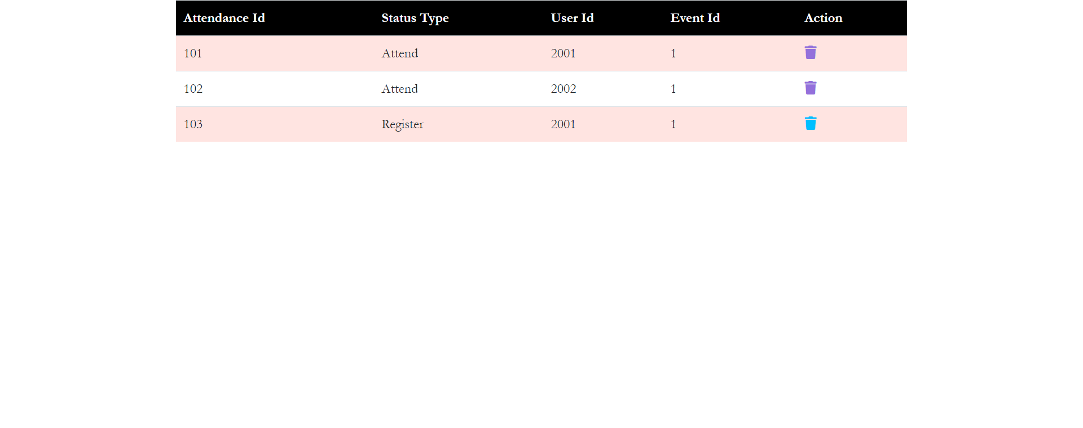

**1.5 User Attends Events**

Users should be able to see the ‘Attend’ button on the right side of the page.

Click the ‘Attend’ button.



The attendance will automatically be added to the attendance list.



**1.6 Event feedback for attendees**

After the user attended an event, they could provide their feedback regarding the event that they attended. The feedback form will be located under the individual Program Details page.

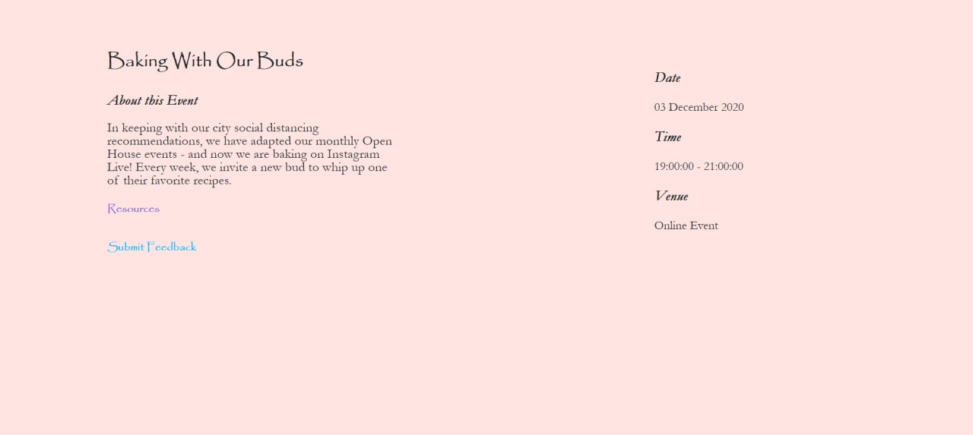

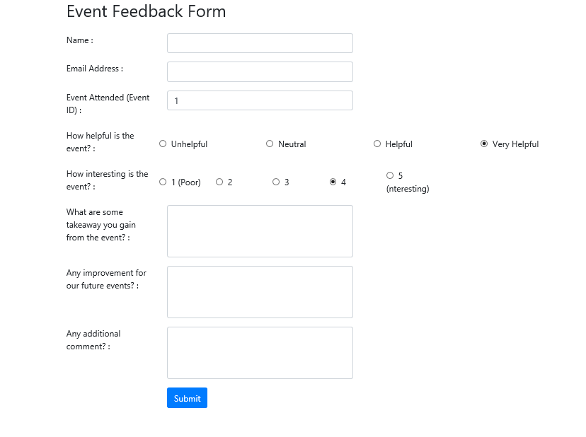

1. **For Admin**
   1. **Users**

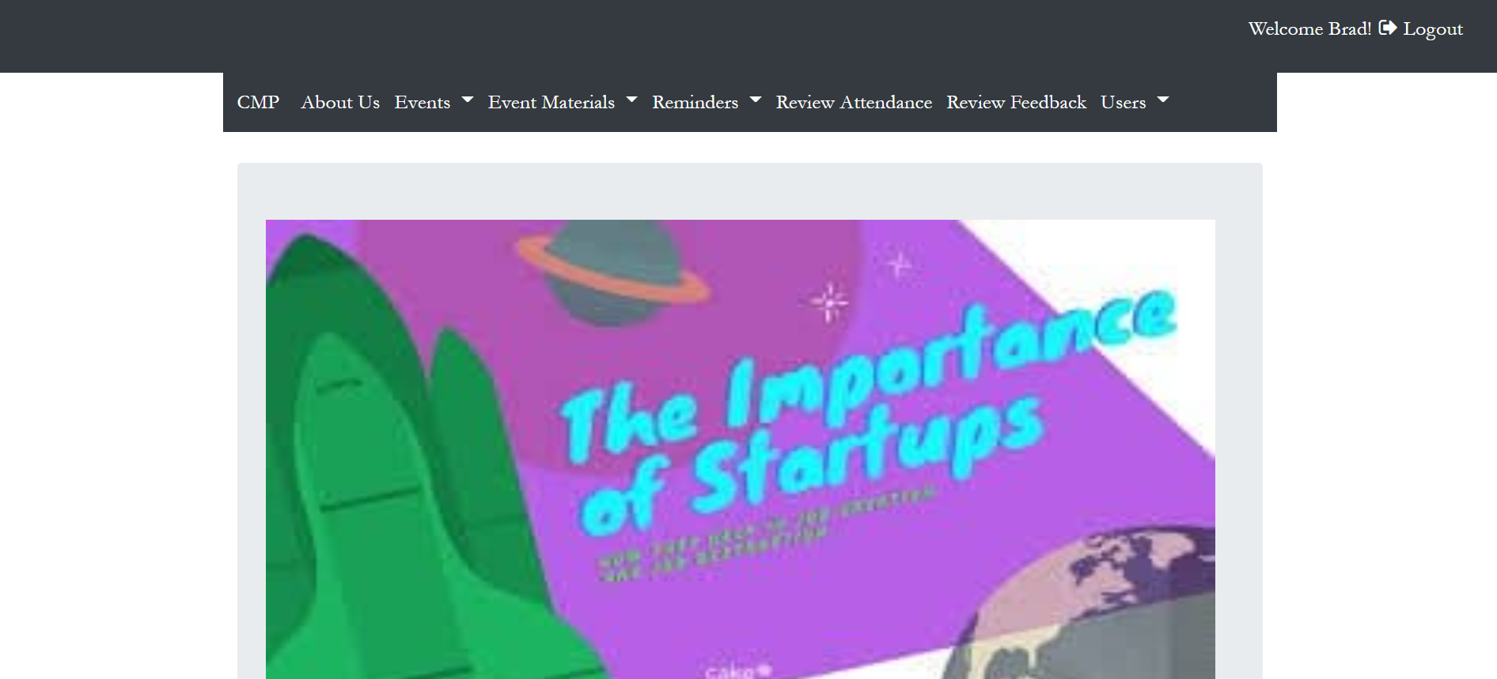

* In the Admin home page of the CMP, admin can be able to view all the users who have registered into the CMP account.
* Admin can click the edit icon to make changes to the user’s account.
* Admin can also delete the user, by clicking the trash icon, which leads to having the user deleted from the database.

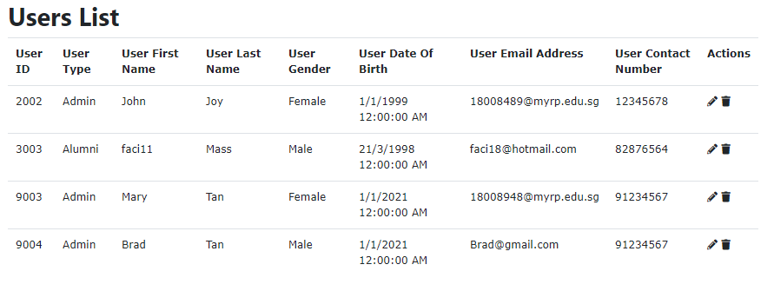

* Admin can go to the UserList page, and click the edit icon to change the user type for the respected account by clicking on the Edit icon to edit into the respective user’s account.

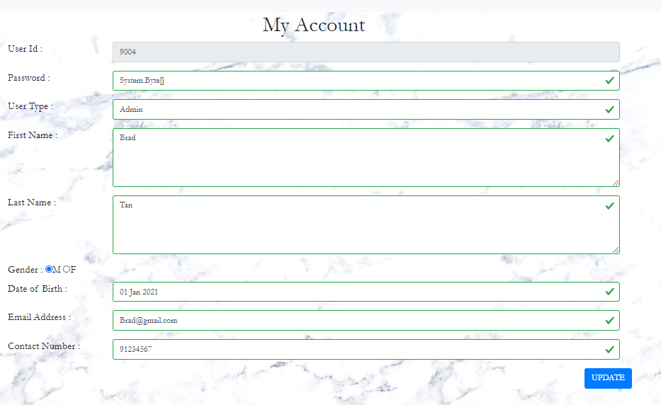

* Admin can click the dropdown of Users tab and click the add user feature, to add a new user, using this add user, will lead the user to be added to the database of the CMP.

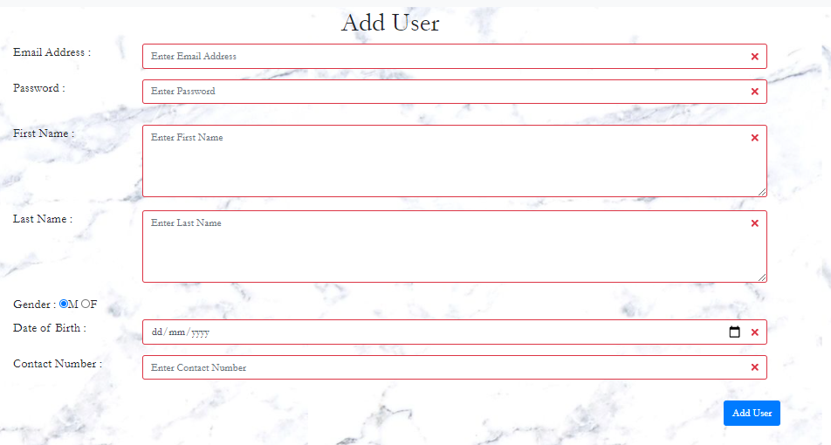

* 1. **Event**

**2.2.1 Upload Event**

From the main page, click the ‘Upload Event’ button. After entering the details for the event, click the upload button to upload the event.

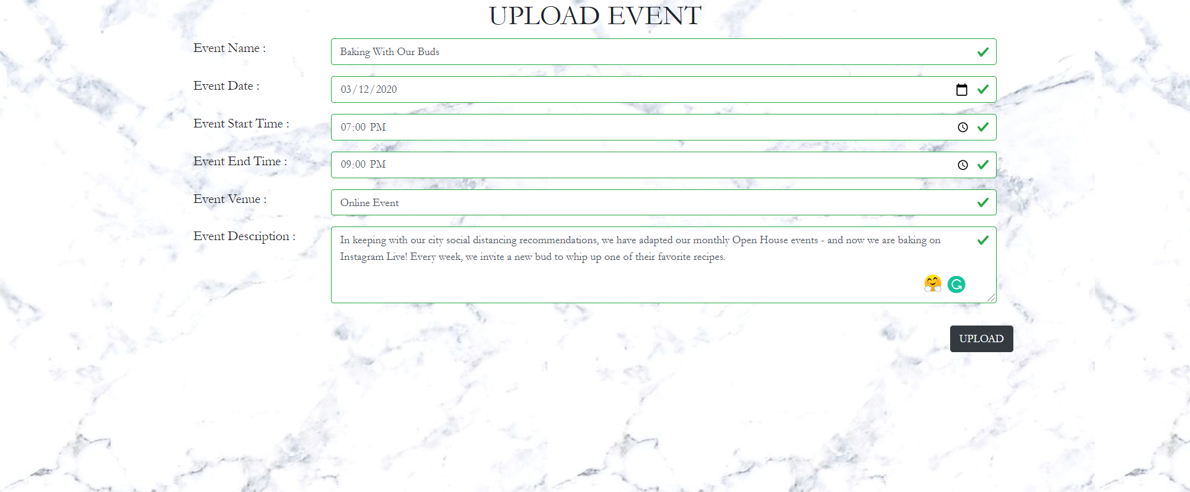

**2.2.2 Programs List**

A message will be shown to indicate that the event has been successfully uploaded in the programs list.

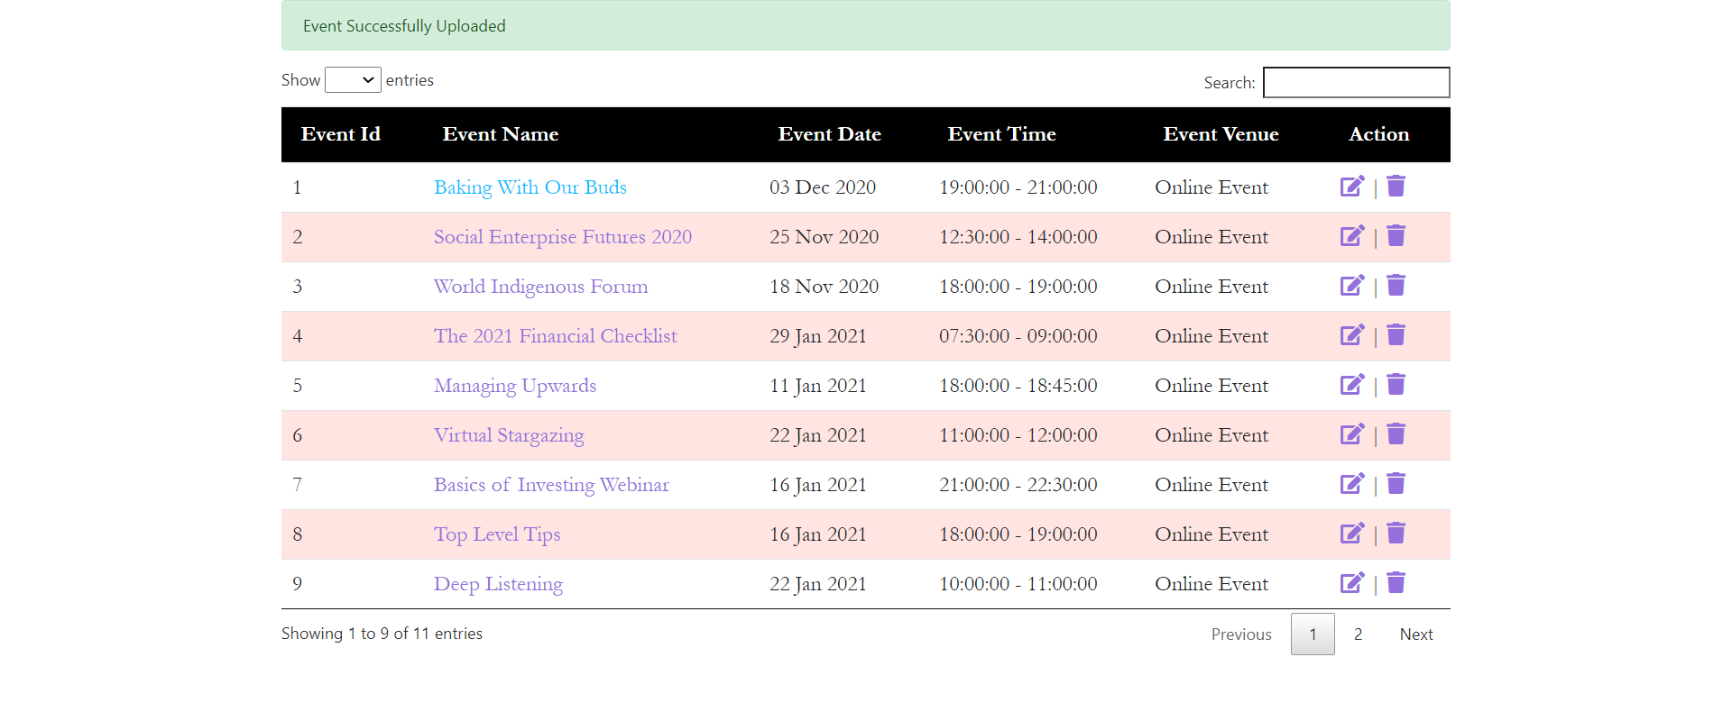

**2.2.3 Update Event**

After clicking the edit button in the programs list, the admin will be redirected to the update event page in which the admin would be able to update the event details. After updating the details for the event, click the update button to update the event.

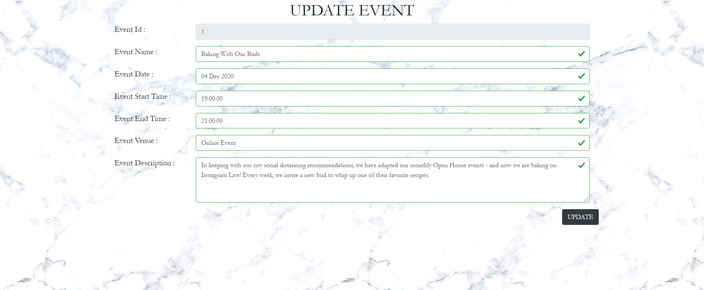

A message will be shown to indicate that the event has been successfully updated in the programs list.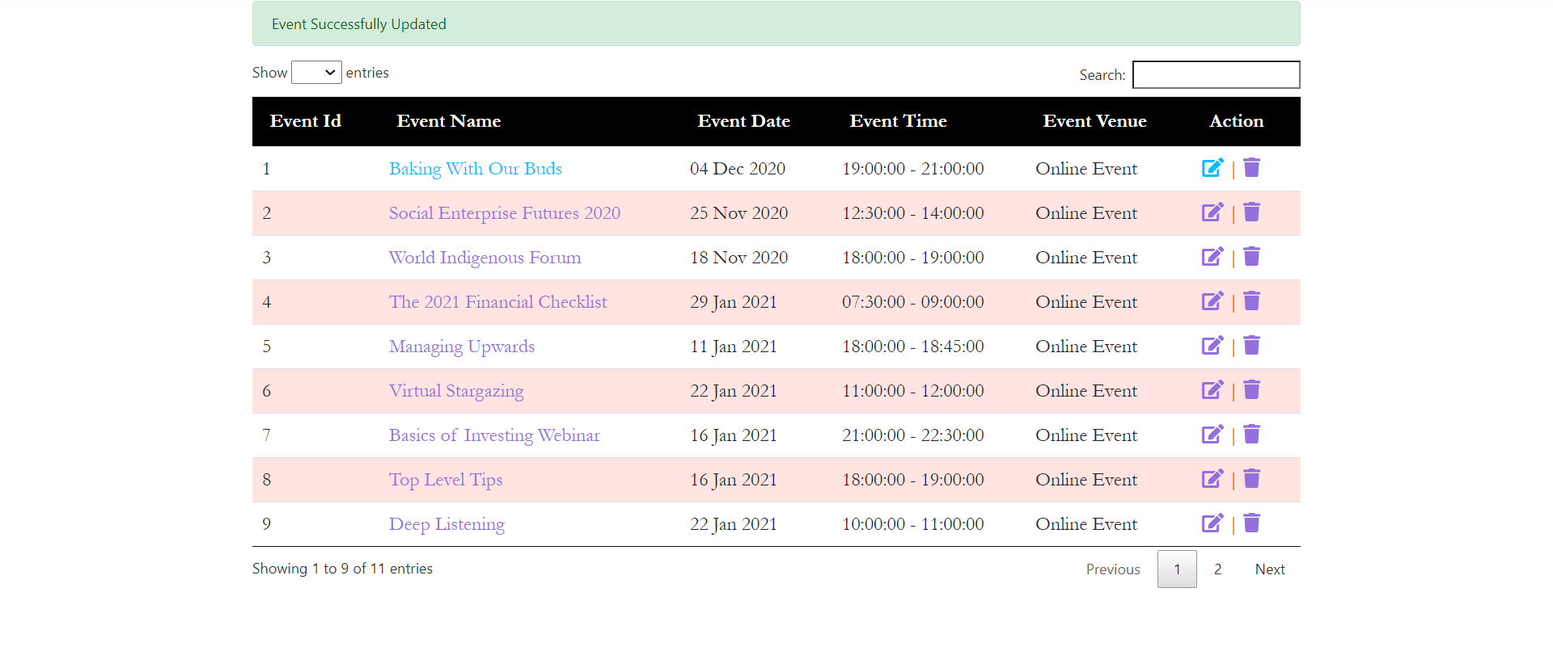

**2.2.4 Delete Event**

After clicking the delete button in the programs list, there would be a confirmation message to delete the event and the event would be deleted.

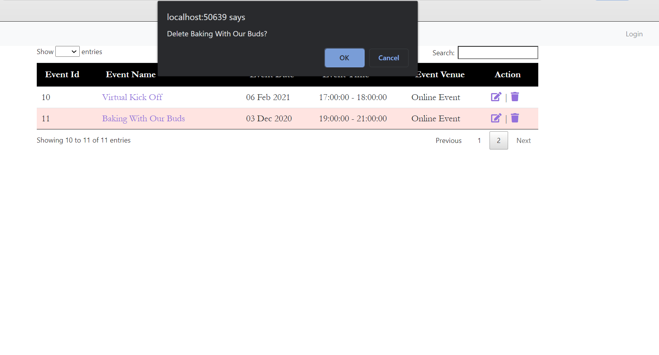

A message will be shown to indicate that the event has been successfully deleted in the programs list.

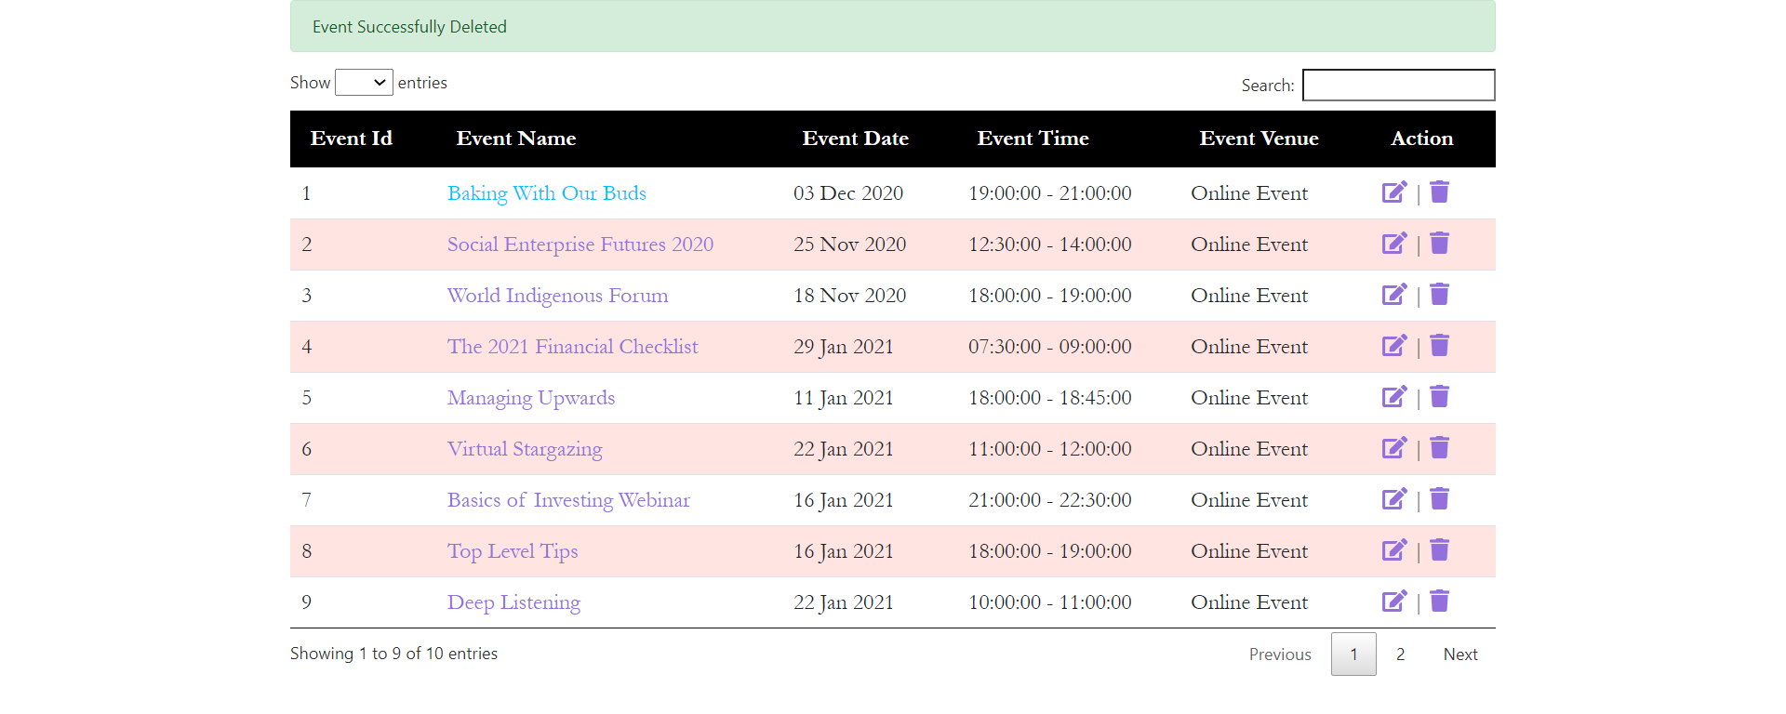

* 1. **Attendance**

**2.3.1 View the Attendance List**

From the main page, click the ‘Attendance’ button. Admin should be able to see this page.

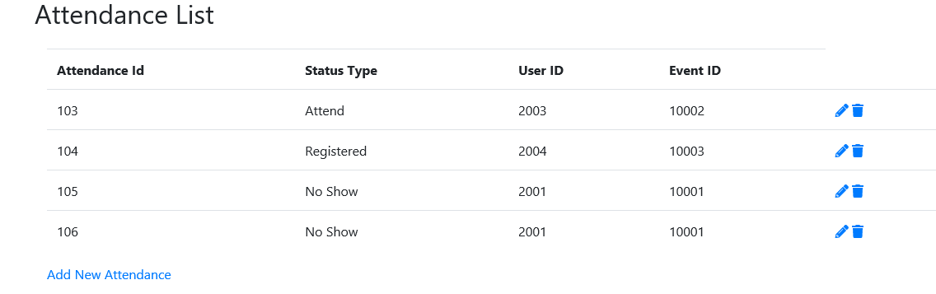

**2.3.2 Add New Attendance**

In order to create new attendance, Admin can click on the ‘Add New Attendance’ link. This page will show up. Admin can enter the Status Type, User ID and Event ID to add a new attendance. Afterwards, click on the ‘submit’ button to confirm.

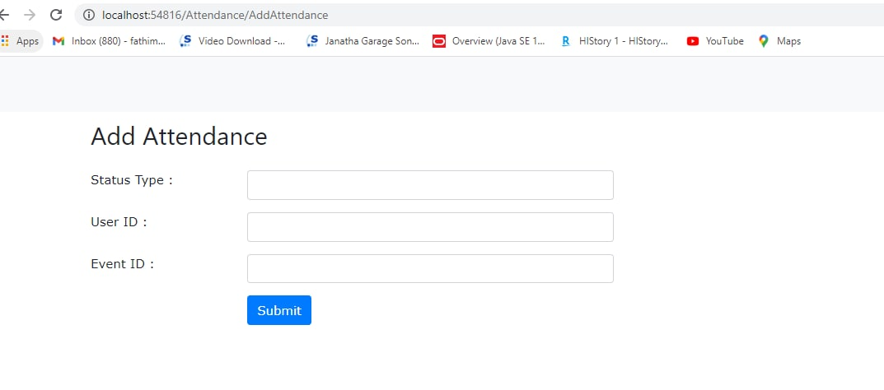

**2.3.3 Edit Attendance**

In order to edit the attendance, admin could click on the “pencil” icon in the Attendance List to change the respective field. (Attendance ID, Status Type, User ID and Event ID). Afterwards, click on the ‘submit’ button to confirm the change.

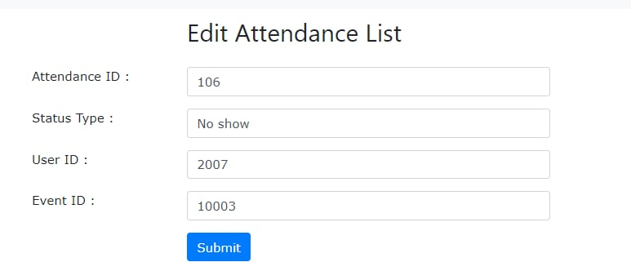

**2.3.4 Delete Attendance**

Admin could also click on the ‘trash’ icon to delete a respective row of user’s information.



* 1. **Upload Materials**

**2.4.1 Upload a new file for an event**

From the main page, click the ‘Upload Materials’ button.

Admin should be able to see this page.

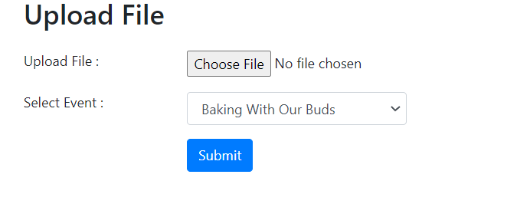

Next, click the ‘Choose File’ button and select the file to upload.

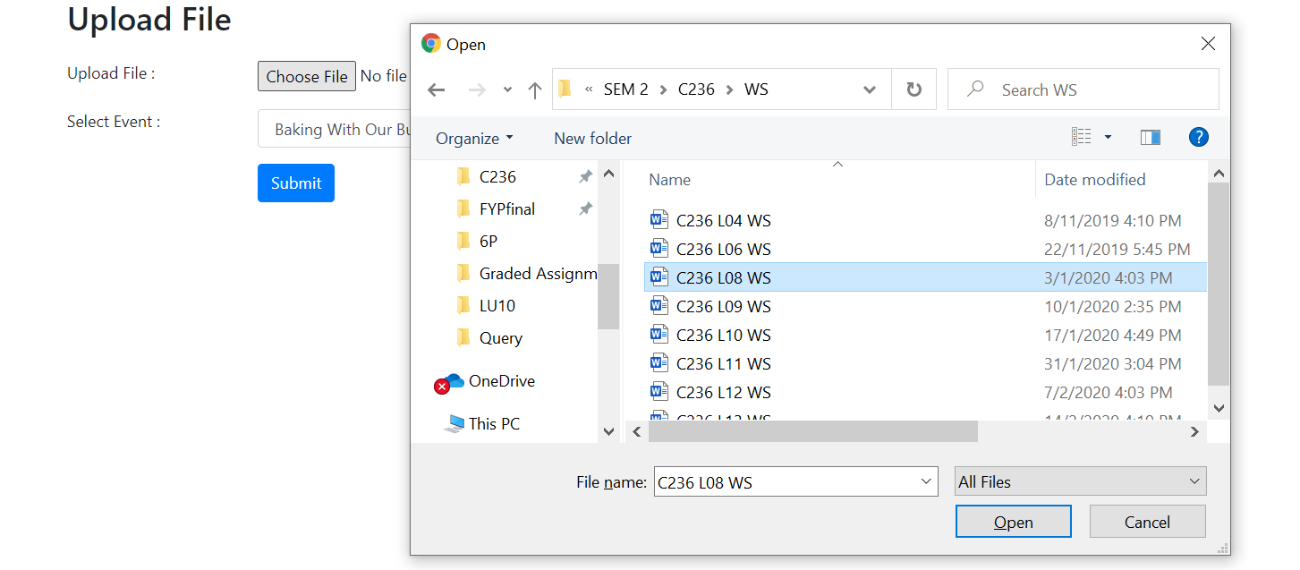

After selecting the file, select the event you want to upload . (Click the arrow for more options)

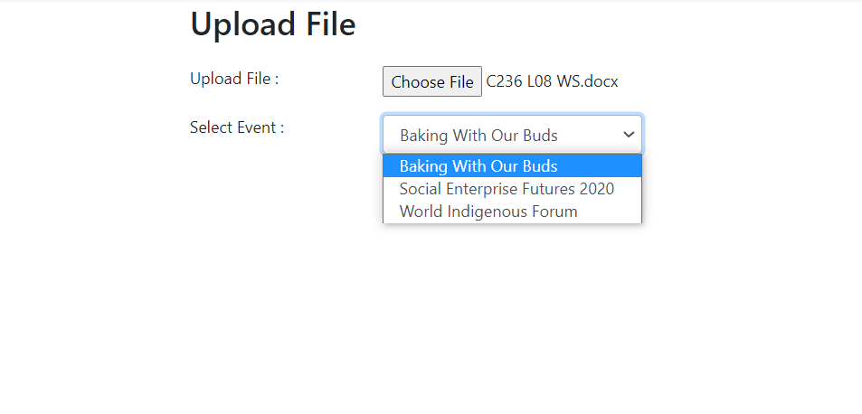

After selecting the event, click submit.

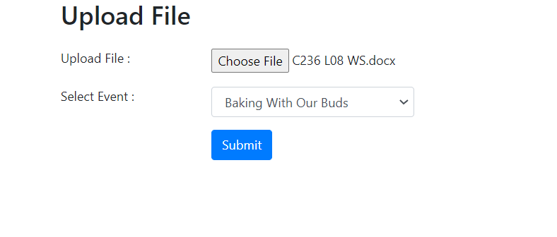

After submit, it redirects the admin to the File Directory page. The admin can see the status in green that shows the file has been uploaded to the system successfully.

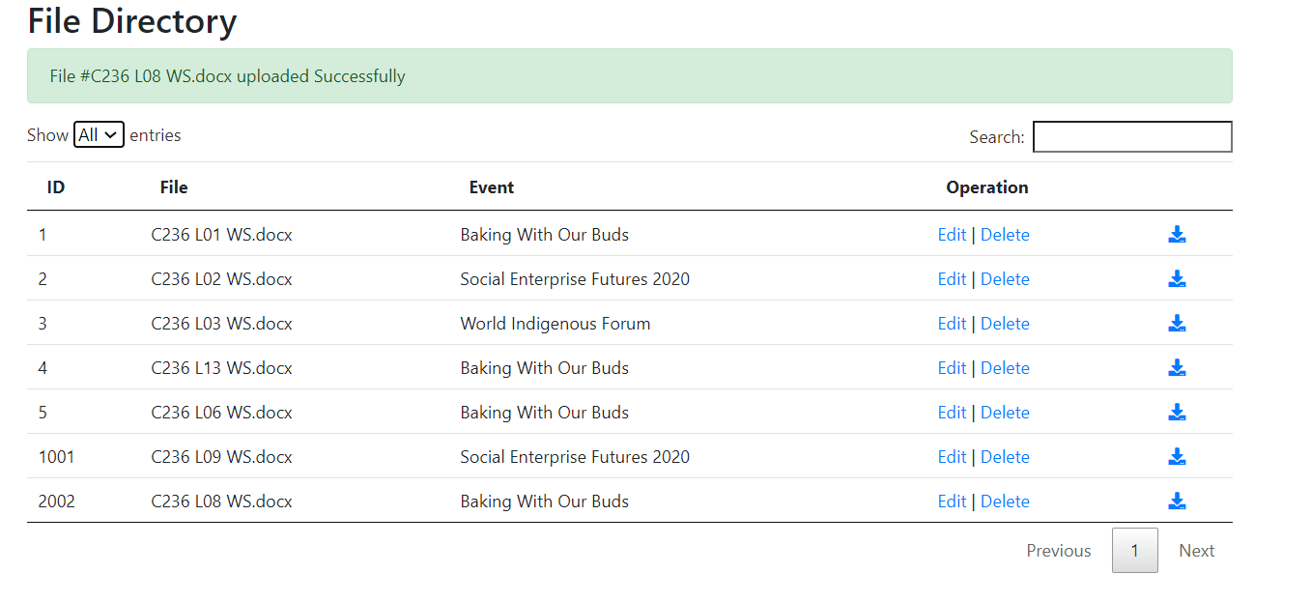

The uploaded file is also displayed in the ‘Resources’ from the ‘Event Details page’. (Go to Events > select event name > select ‘Resources’ )

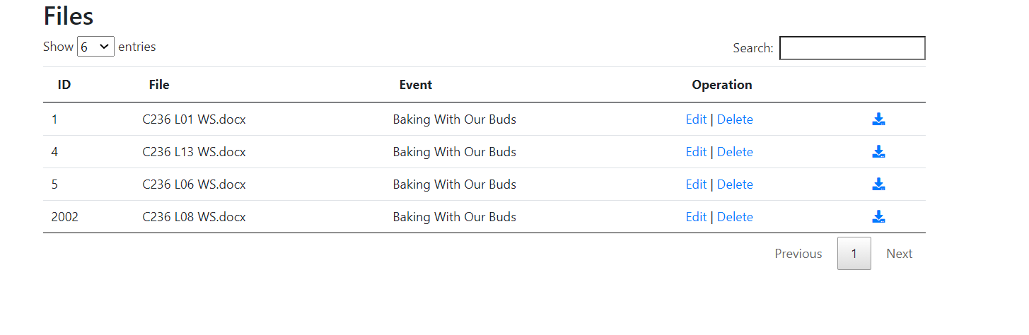

**2.4.2 View Files**

From the main page go to ‘File Directory’

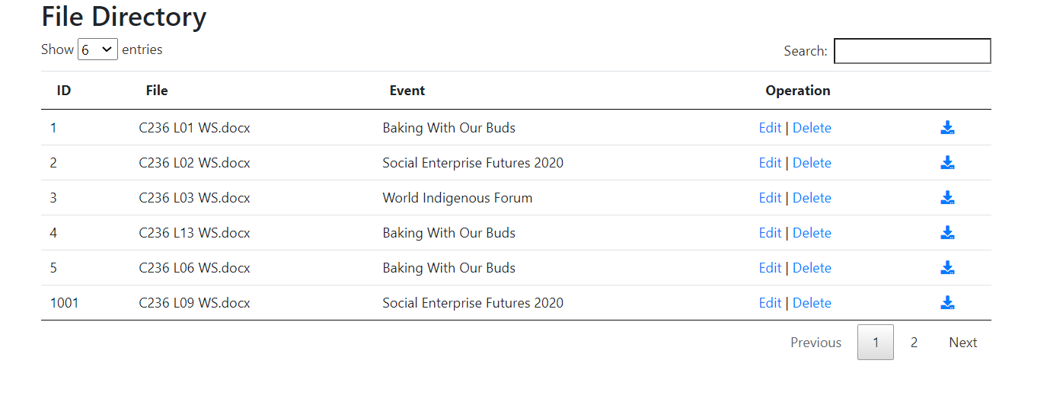

**2.4.3 Update**

Go to ‘File Directory’



For each file in the table there is an “Edit | Delete ”function under the operation. For this case the admin wants to relocate file ‘C236 L01 WS’ from event ‘Baking with Buds’ to ‘Social Enterprise Futures 2020’. Click ‘Edit’



After clicking ‘Edit’ the admin sees this page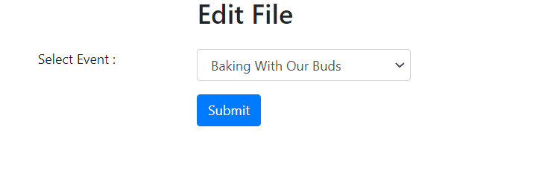

Next, select the event to change. Click the arrow for more options.

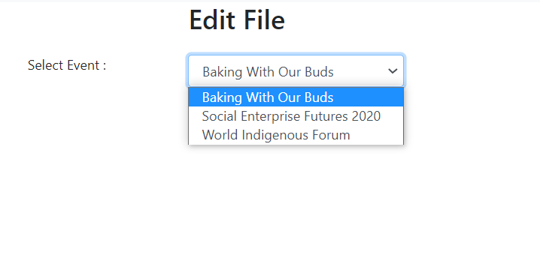

After selecting the event, click submit.

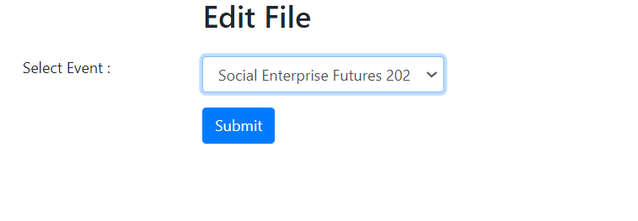

It should redirect back to the File Directory where there should be a status in green displayed to show that the file has successfully been relocated to another event.

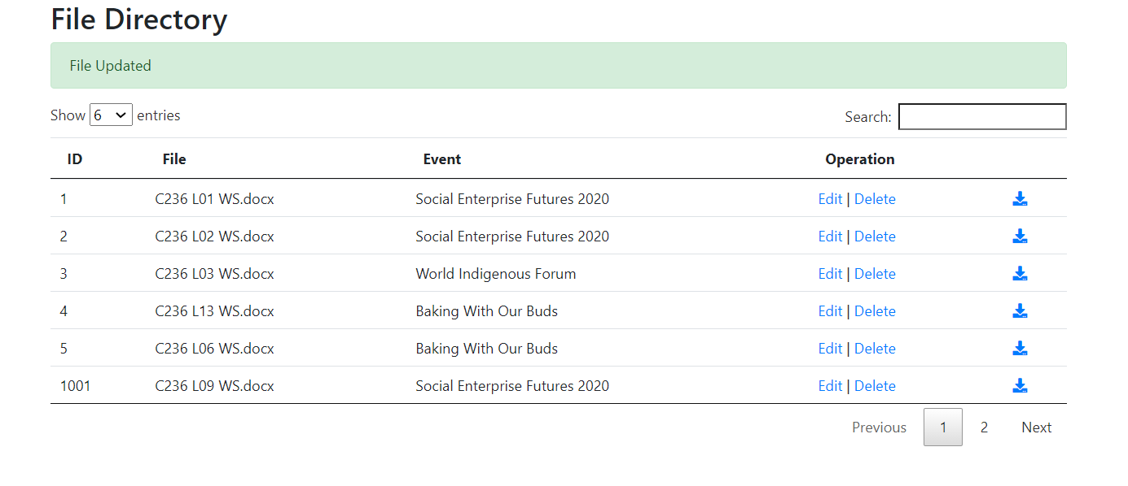

**2.4.4 Delete**

Go to ‘File Directory’. To delete the file, click ‘Delete’.

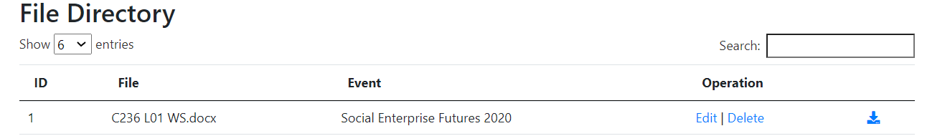

There will be a pop up message stating the file name the admin will delete . Click ‘OK.’

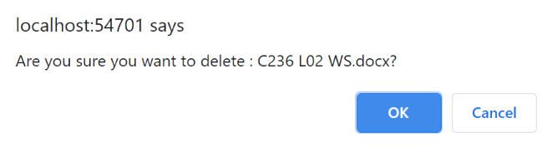

After deleting, the system will return to the File Directory showing the status in green which indicates that the file has been deleted.

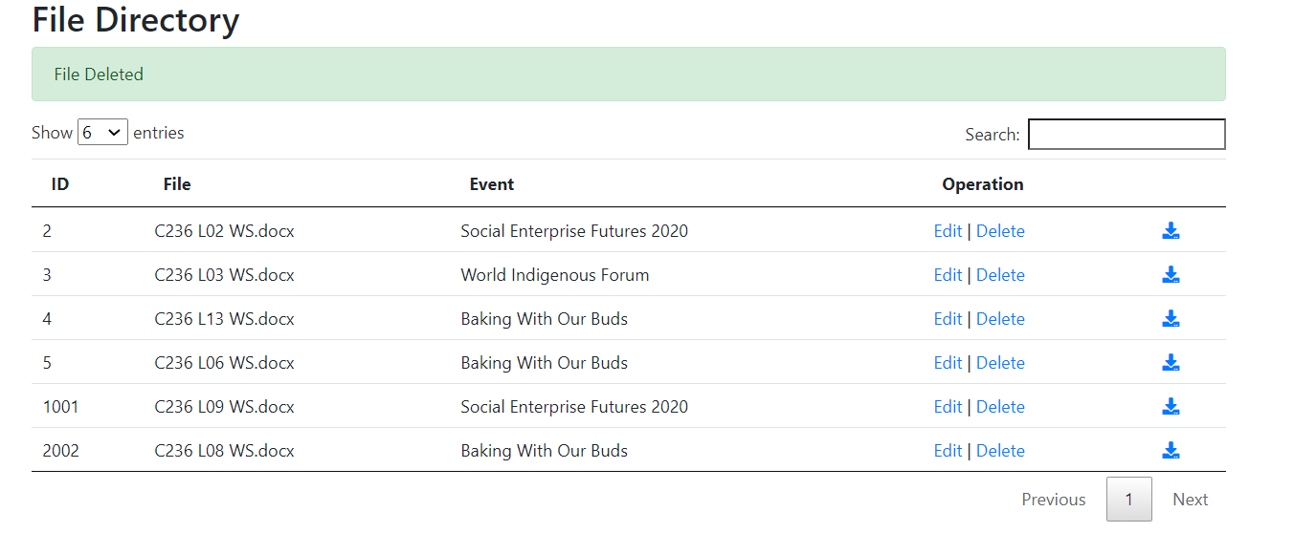

**2.5 View Feedback Response**

2.5.1 After a user attended an event and completed the feedback regarding the event, Admin could view the list of responses under the Admin home page of ‘Review Feedback’. Admin could also do a sort and search based on the information they want.

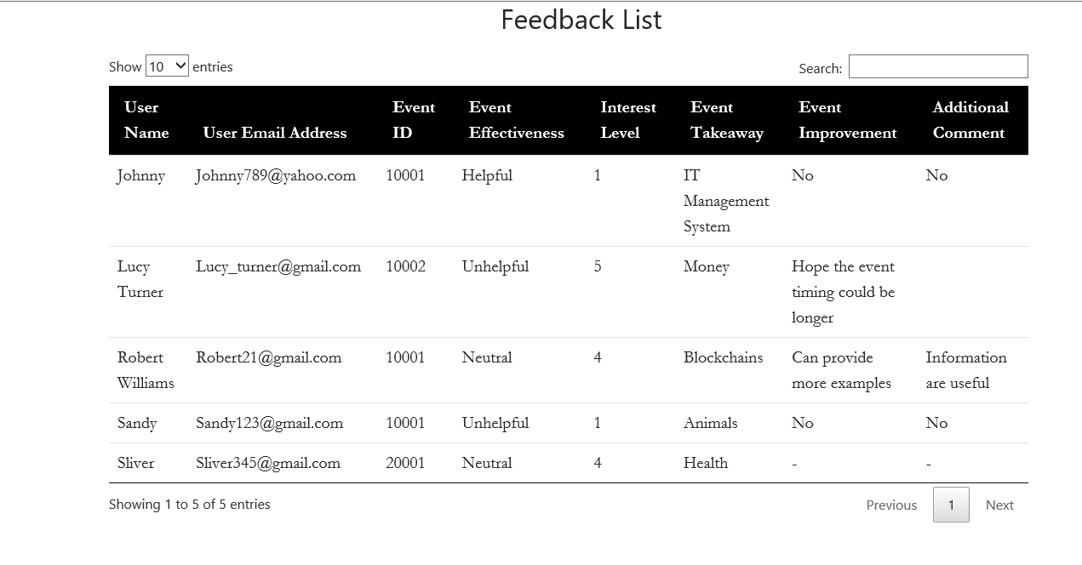

**2.6 Automated reminders**

**2.6.1 View Reminder list**

From the Admin main page go to ‘Reminders’. From there you should be able to see a list of reminders with the heading ‘Send Reminders List’ below :

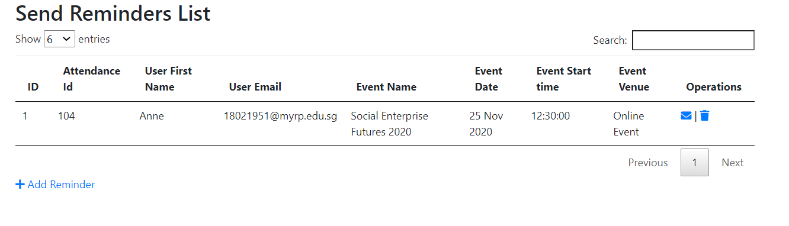

**2.6.2 Send reminder to attendee**

From the ‘Sender Reminders List’, admin should be able to see 2 icons in the operations column

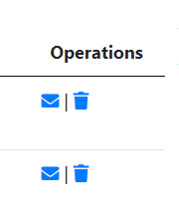

Click the ‘envelope’ icon as shown above and it will redirect the admin to another page ‘Send Reminders’

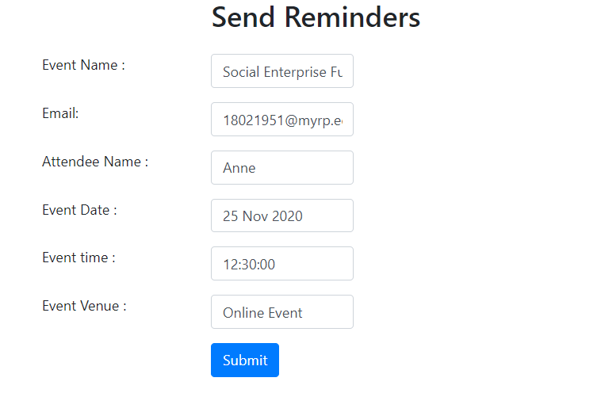

The following inputs (Event name, email etc) have been automatically filled in for the admin, so the admin does not need to make any of the changes. Then click on submit.

From the Outlook Email admin should be able to see the following :

Inbox View :

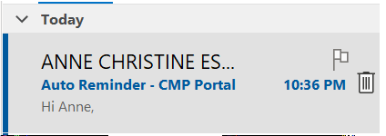

Message view :

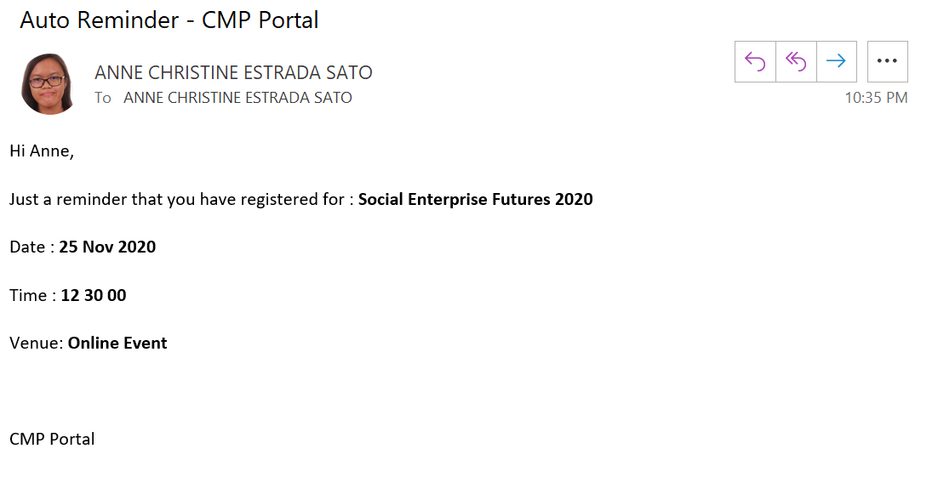

**2.6.3 Add reminder (add Attendee into reminder list)**

Go back to the ‘Send Reminders List’ and view the ‘Add Reminders ’ which is under the list.



It should look like this in close-up view :



Click the ‘Add Reminder’ link and it will redirect you to another page ‘Add Reminders’.

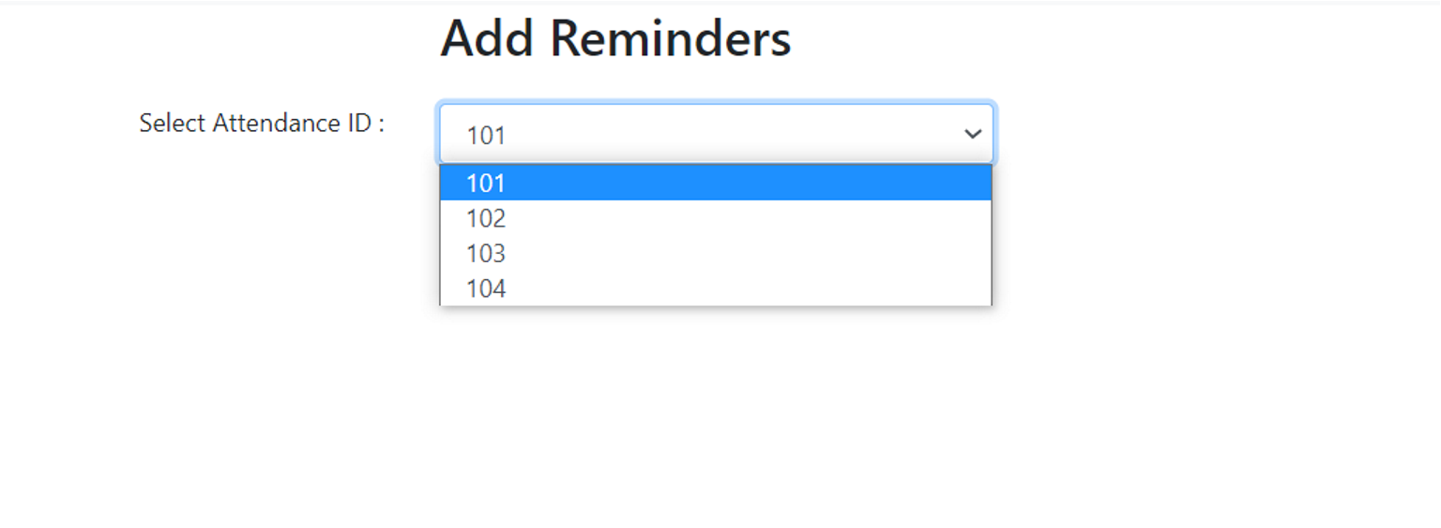

From here, the admin selects any Attendance ID he or she wishes to add into the ‘Send Reminder’ list

For example, Attendance ID 101 is selected.

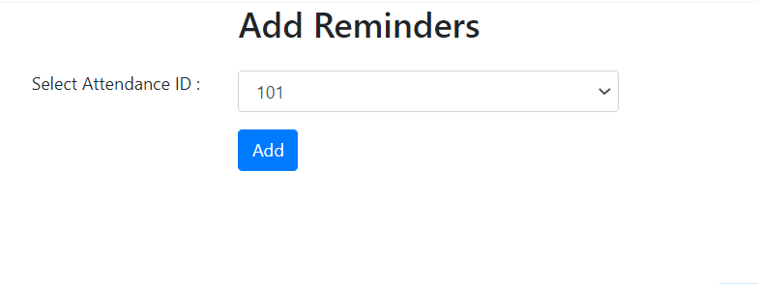

Then, click ‘Add’.

After that, the admin should see this result below :

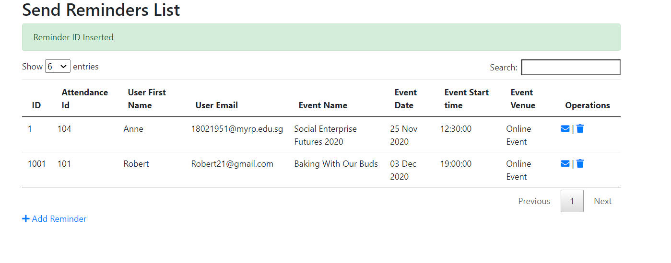

This is to confirm that a new Attendance ID has been inserted into the Send Reminders List and that can be used to send reminders to the new attendee.

**2.6.5 Delete Reminders**

If the admin wishes to remove the Attendee from the Reminders List, go to the operations column and select the trash icon.

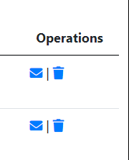

There will be a pop up message like this :

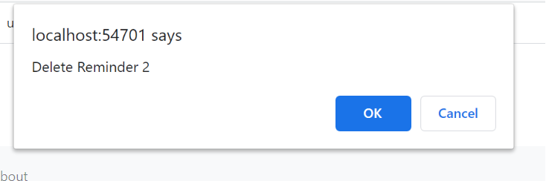

Click ‘OK’ and the result should look like this :

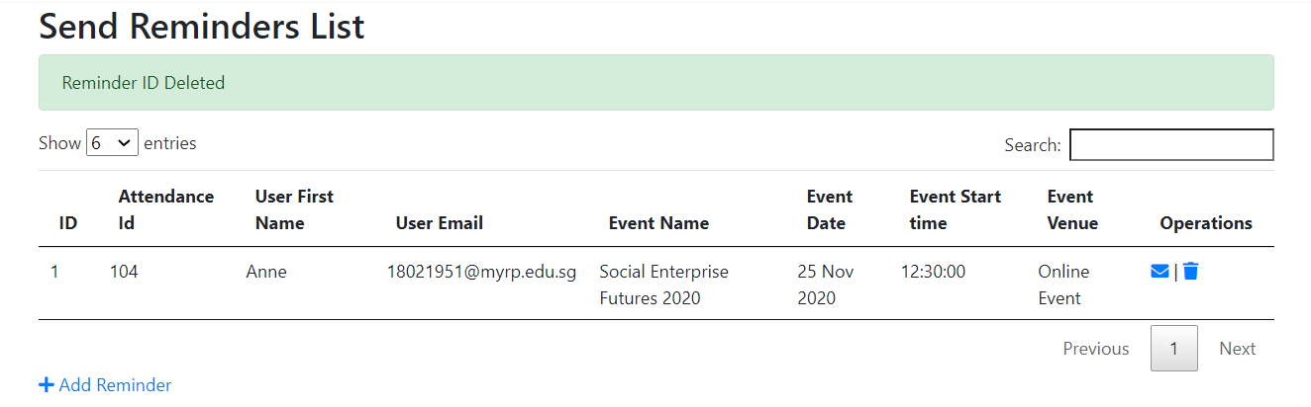

This confirms to show that the Reminder ID for a particular Attendee has been removed and can no longer be used to send reminders unless added.

## **6.2** **Technical Documentation (Installation guide/Manual)**

# **7** **Conclusions**

**Section Explanation:** This is the section where you should state the main take-away points from your project. It should be more information than the abstract. You should include a concise version of your accomplishments, what problems you had, and what could be done in the future to rectify them.

• Summary of Accomplishments

• Future Work

**Accomplishments**: We have built the Cohort Management Portal (CMP) so that users such as Startup Founders, Alumni, & Admin of CMP, can be able to view programs that were conducted by the Tribe Accelerator Company anywhere and anytime via online since this CMP is a website which can be accessed through internet connection.

We have developed many functions in the CMP such as in order for users to view all the programs, they have to firstly register into the CMP (we create the Register form page). In order to access the CMP home page, firstly users need login (we created the login page). In addition, CMP users not only are able to view the programs list but also they can click the register icon to register for a particular event from the Programs List (Sign up for event) and also user can also click the Attend icon to attend for the programs and these registered or attend status will be automatically updated in the attendance list for the respective user. Furthermore, Users can be able to access the program materials by downloading files (we have created the Download feature).

In terms of functions which only can be accessed by the Admins of CMP, such functions like under events there are Upload event & Update event(Edit/Delete), under event materials there are Upload File, Download Files & Update Files. Under Reminder, there are upload reminders (send reminder) & Update Reminder. Under Review Attendance there are Attendance List (Edit/Delete) & Add attendance. Under Review Feedback, it displays a feedback list. Under Users there are add user and Users List (Edit user account & Delete user)

**Problems**:

Some problems we had during the development process of the CMP, are firstly we could not able to display the My Account page inside home page because we couldn't able to separate my account form page from the user list means that since normal users should not have the access to view the users list, thus only admin can access the user list to manage users account. But we plan that inside the home page for users, there will be a standalone tab called My account for the user to update their particulars. However we could not able to display the my account page form with auto filled fields of user’s particulars, so as a team conclusion since that's the only problem we faced we plan to avoid it by trying to remove that stand alone tab of My account in the home page so now if the admin want to change the user’s type inside user’s respective account then the admin can visit the userlist page inside the admin home page and click the edit icon to make the following changes.

Another issue was in Event Materials, the files cannot be used to update the database, it can only be viewed, uploaded and deleted. One strategy was to change the file’s designated location. This strategy might help to solve the issue, however one disadvantage of this is that if the admin needs to change the file due to uploading the wrong file, he or she has to delete the file and upload another file.

To fix this ”My account” error in the future, we can get help from professional programmers such as our RP facilitator or external programmers outside RP, to be able to identify the problem of not able to display the My account page without the use of the User list.

# **References**

* *Tribe Accelerator Home – Tribe*. (n.d.-b). Tribe Accelerator. <https://tribex.co/accelerator/>
* Tribe. (n.d.). *Tribe LinkedIn*. <https://sg.linkedin.com/company/tribe-network>
* *Tribe Accelerator*. (n.d.). Forbes. <https://www.forbes.com/profile/tribe-accelerator/?sh=1df425531cda>
* Tribe. (n.d.-a). *Tribe Accelerators : Competitors, Clients, Business Models & Metrics*. Tribe Accelerator. <https://edgebase.fabernovel.com/companies/tribe-accelerator>

# **Appendices**

**Section Explanation:** This is for you to include materials which you could not put in the main body of your report. For example, you could include source code of your project.

Appendices should be headed by letters in alphabetical order, ie. Appendix A, Appendix B, etc.

# **Project Poster**

**Section Explanation:** Pls create a poster write-up for your project. The file should be saved as a PPT file and embedded in this section as an object.

[2020 Project Poster.pptx](2020%20Project%20Poster.pptx)